**Synopsis of Major Project (KCA353)**

**On**

## **Stock Market Price Prediction**

## **MCA-II Year/IV Semester**

**Submitted by**

Kunal Gaurav Sisodiya -2101640140058

Malay Gupta -2101640140061

Aman Tiwari -2101640140010

Mohd. Waseem -2101640140066

Jitendra Shukla -2101640140043

## **UNDER THE SUPERVISION OF**

**Mr. Rahul Bajpai**

**(Assistant Professor)**

**PRANVEER SINGH INSTITUTE OF TECHNOLOGY**

**Pranveer Singh Institute of Technology**



 To the

**DR A.P.J ABDUL KALAM TECHNICAL UNIVERSITY, LUCKNOW**

**SESSION 2022-2023**

**INDEX**

|  |  |  |
| --- | --- | --- |
| **S. no.** | **Title** | **Page no.** |
| 1 | Introduction | 1 |
| 2 | Project Scope | 2 |
| 3 | Aims & Objective | 3 |
| 4 | Module Description | 4 |
| 5 | Tools & Technology Used | 5-6 |
| 6 | Methodology   * 1. Backend   2. Frontend   6.3 Data Flow Diagram (DFD) | 7-10 |
| 7 | Expected Time Schedule (Gantt Chart) | 11 |
| 8 | Impact of proposed system in Academics& Industry | 12 |
| 9 | Roles & Responsibility | 13 |
| 10 | Pros & Cons | 14-15 |
| 11 | Conclusion | 16 |
| 12 | References | 17 |

# INTRODUCTION

* Stock price prediction is the process of using historical data and statistical models to forecast the future prices of stocks. The stock market is a complex system, influenced by a variety of factors such as company earnings, economic indicators, news events, and geopolitical factors. Predicting stock prices accurately is challenging, but it can be useful for investors and traders who want to make informed decisions about buying and selling stocks.
* Machine learning is an application of artificial intelligence (AI) that provides systems the ability to automatically learn and improve from experience without being explicitly programmed. Machine learning focuses on the development of computer programs that can access data and use it to learn for themselves.
* The process of learning begins with observations or data, such as examples, direct experience, or instruction, in order to look for patterns in data and make better decisions in the future based on the examples that we provide. The primary aim is to allow the computers to learn automatically without human intervention or assistance and adjust actions accordingly.
* Stock price prediction is a challenging and exciting field that has attracted the attention of researchers and practitioners in finance, machine learning, and artificial intelligence are helpful in this.

**PROJECT SCOPE**

* This project will focus exclusively on predicting the daily trend (price movement) of individual stocks. The project will make no attempt to deciding how much money to allocate to each prediction.
* A system is essential to be built which will work with maximum accuracy and it should consider all important factors that could influence the result.
* The goal of this project is to predict a stock price of a company according to it’s previous historical data. Stock Market Prediction is composed of main components: a company’s historical data of stock which will help to analyse the current and previous changes of stock price.
* The above proposed model is easy to implement considering the available technology infrastructure. The model is simple, secure and scalable.
* The proposed model is based on serial communication.
* These model will help the investers to invest their money according to the predicted value.

# AIMS AND OBJECTIVES

* To develop an accurate model for predicting stock prices.
* To use machine learning and statistical analysis techniques to improve the accuracy of the model.
* To help investors make informed decisions by providing them with reliable predictions of stock prices.
* Collect historical stock market data for the company/stock of interest.
* Clean and preprocess the data to remove any inconsistencies and outliers.
* Develop a machine learning model (e.g. regression, neural network) to predict future stock prices based on the historical data.
* Train and validate the model using a portion of the data, and test its accuracy using the remaining data.
* Fine-tune the model to improve its accuracy and reduce any overfitting.
* Evaluate the performance of the model using various metrics (e.g. Mean Absolute Error, Root Mean Squared Error).

**MODULES**

1. **Linear Regression:** This is a simple and widely used technique for stock price prediction. It involves fitting a linear equation to the historical data and using it to predict future prices.
2. **Random Forest Regression:** This is a popular ensemble learning technique that uses multiple decision trees to make predictions. It is often used for stock price prediction due to its ability to handle non-linear relationships between variables.
3. **Support Vector Regression:** This is a powerful regression technique that is often used for stock price prediction. It works by mapping the data to a high-dimensional space and finding the hyperplane that best separates the data into different classes.
4. **Long Short-Term Memory (LSTM):** This is a type of recurrent neural network (RNN) that is often used for time series analysis and prediction. It is well-suited for predicting stock prices as it can capture long-term dependencies and handle non-linear relationships between variables.
5. **Convolutional Neural Networks (CNNs):** This is a type of neural network that is often used for image analysis, but can also be used for time series analysis. It is often used for stock price prediction due to its ability to identify patterns in the data.

# TOOLS AND TECHNOLOGY USED

* **TOOLS:**

1. **TensorFlow:** TensorFlow is a popular open-source machine learning library developed by Google. It is commonly used for deep learning tasks such as image recognition and natural language processing, but it can also be used for stock market price prediction using neural networks.
2. **Keras**: Keras is a high-level neural network API written in Python that can run on top of TensorFlow, CNTK, or Theano. It is designed to enable fast experimentation with deep neural networks and is commonly used for stock market price prediction using LSTM and other types of neural networks.
3. **PyTorch**: PyTorch is another popular open-source machine learning library that is widely used for deep learning. It is known for its dynamic computational graph and is commonly used for stock market price prediction using neural networks.
4. **Prophet**: Prophet is an open-source time series forecasting library developed by Facebook. It is designed to handle seasonality, trends, and other time series characteristics and is commonly used for stock market price prediction.

* **TECHNOLOGY:**

1. **Python**: Python is a popular programming language for machine learning due to its simplicity, flexibility, and large collection of libraries for data analysis and machine learning. Some commonly used Python libraries for stock price prediction include scikit-learn, TensorFlow, Keras, and PyTorch.
2. **R**: R is another popular programming language for data analysis and machine learning. It has a large collection of libraries for statistical analysis and visualization, and it is often used in the finance industry for data analysis and risk management.
3. **Big data platforms**: With the increasing volume and velocity of financial data, big data platforms such as Hadoop and Spark are becoming more important for stock price prediction. These platforms can handle large datasets and provide distributed computing capabilities for processing and analyzing data.
4. **Natural Language Processing (NLP):** NLP techniques can be used to analyze news articles, social media sentiment, and other textual data that may affect stock prices. Some commonly used NLP tools and technologies include NLTK, spaCy, and Gensim.
5. **Deep learning:** Deep learning techniques such as convolutional neural networks (CNNs) and recurrent neural networks (RNNs) have shown promise for stock price prediction due to their ability to capture complex patterns and relationships in the data.

**METHODOLOGY**

1. **Data collection:** The first step is to collect historical data on the stock price and other relevant factors that could affect the stock price, such as economic indicators, news articles, and social media sentiment.
2. **Data preprocessing**: The collected data needs to be cleaned, preprocessed, and transformed to make it usable for machine learning algorithms. This may involve removing missing or erroneous data, scaling the data, and converting categorical variables into numerical features.
3. **Feature engineering**: This involves selecting and creating features that are relevant and informative for the machine learning algorithms. Some examples of features for stock price prediction could be technical indicators such as moving averages, trading volume, and volatility.
4. **Model selection**: There are various machine learning algorithms that can be used for stock price prediction, such as linear regression, decision trees, support vector regression, and neural networks. The choice of model will depend on the specific problem and data characteristics.
5. **Model training and validation**: The selected model is trained on the historical data, and its performance is evaluated on a validation set to assess its accuracy and generalization capability.
6. **Model testing and deployment**: Once the model is trained and validated, it can be tested on new data to make predictions about future stock prices. The model can be deployed in a production environment to make real-time predictions and inform investment decisions.

**DATA FLOW DIAGRAM**

**LEVEL 0:**

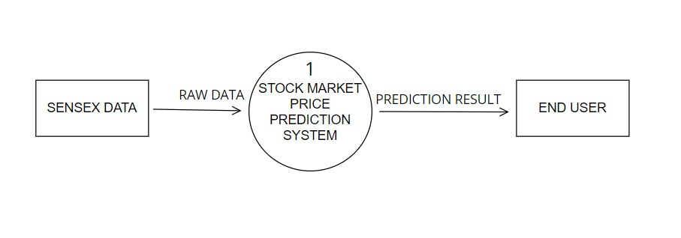

**LEVEL 1:**

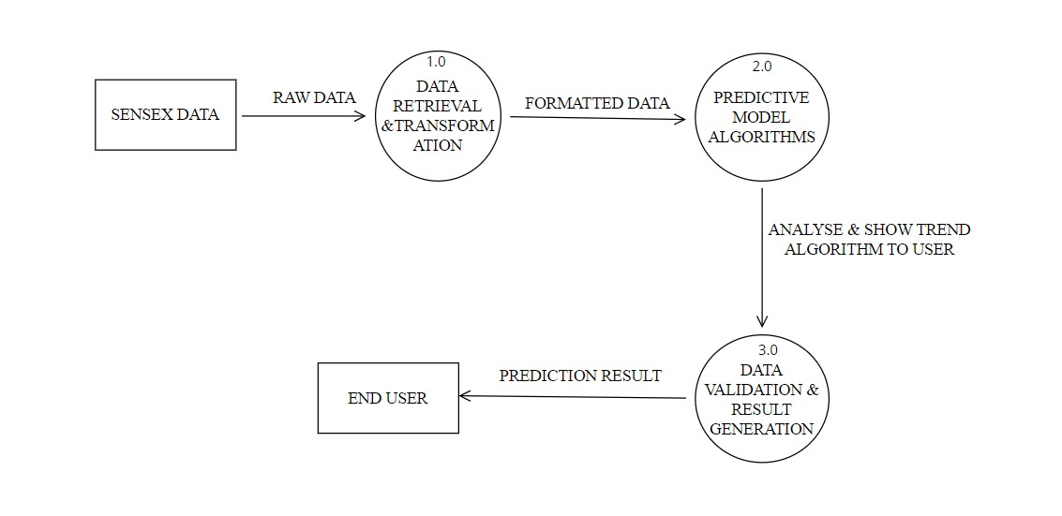



**LEVEL 2:**

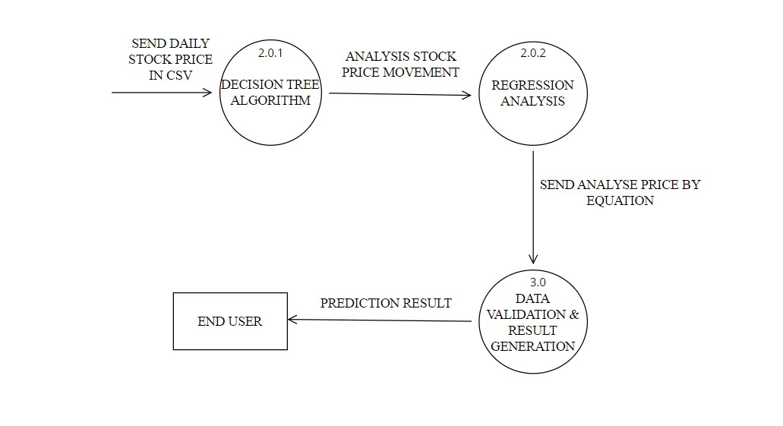

# EXPECTED TIME SCHEDULE (Gantt Chart)

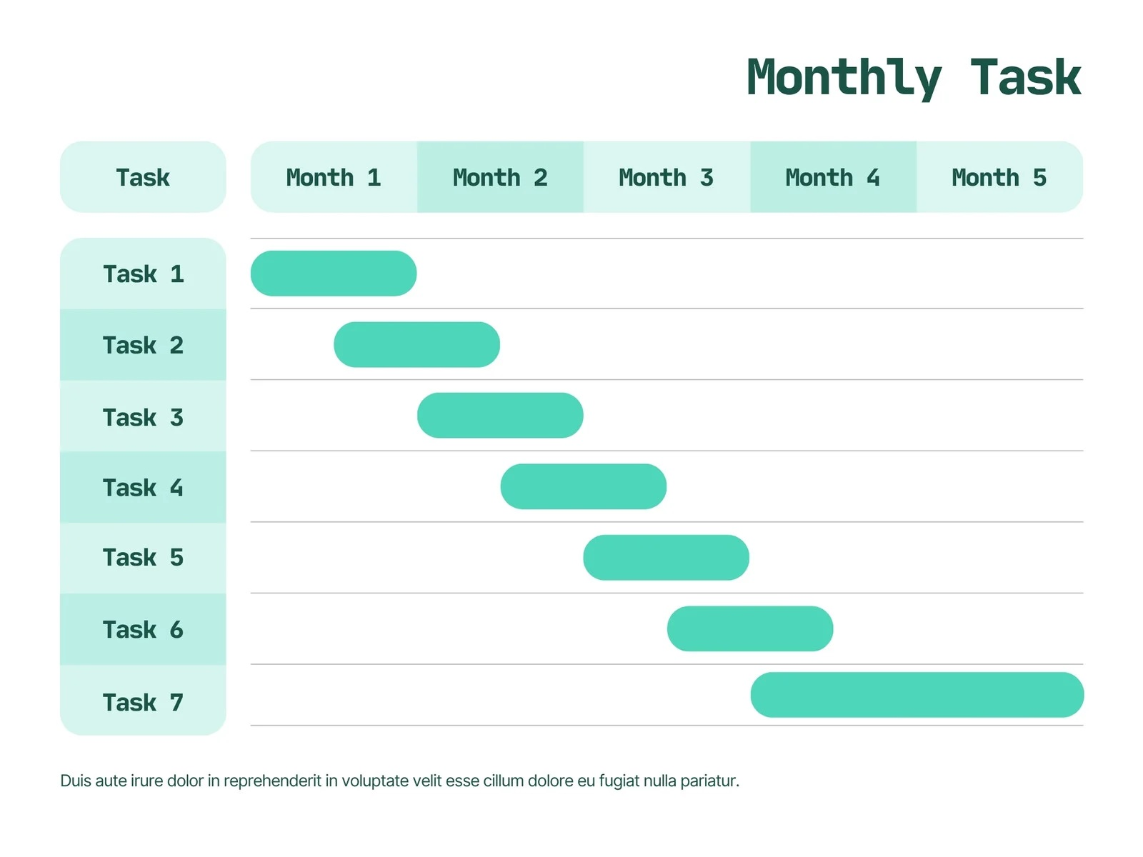

**IMPACT OF PROPOSED SYSTEM IN ACADEMIC AND**

# INDUSTRY

1. Conducting a stock price prediction project can help students develop a range of skills, including data analysis, statistical modelling, programming, and problem-solving. These skills are highly valuable in a variety of fields, particularly in finance and related industries.
2. Undertaking a stock price prediction project provides students with an opportunity to apply theoretical concepts learned in class to real-world scenarios. This can help students to gain a better understanding of how financial markets work and the challenges associated with predicting stock prices.
3. Stock price prediction projects can involve collaboration between students and faculty members, as well as with industry professionals. This can help students to develop professional networks and gain exposure to different perspectives and approaches.
4. Stock price prediction can help investors make informed investment decisions. By analysing trends and patterns in stock prices, investors can decide whether to buy, hold or sell shares of a particular company. Accurate predictions can result in better investment outcomes and higher returns on investment.
5. Predicting stock prices can help companies manage their risk exposure by identifying potential risks and opportunities. For example, if a company predicts a decline in its stock price, it may decide to sell its shares before the price drops further, thereby reducing its exposure to risk.
6. Companies that are able to accurately predict stock prices may have a competitive advantage over their rivals. By making better investment decisions and managing risk effectively, these companies can outperform their competitors in the stock market.

# ROLES AND RESPONSIBILITY

|  |  |
| --- | --- |
| Backend | Kunal Gaurav Sisodiya |
| Backend | Malay Gupta |
| Frontend | Aman Tiwari |
| Frontend | Md. Waseem |
| Frontend | Jitendra Shukla |

# PROS AND CONS

**Pros:**

1. **Improved accuracy**: Machine learning algorithms can analyze large amounts of historical data and identify complex patterns and relationships that may not be apparent through traditional analysis. This can lead to more accurate predictions of future stock prices.
2. **Faster analysis**: Machine learning algorithms can quickly analyze large datasets, allowing traders and investors to make faster decisions and take advantage of opportunities in the market.
3. **Automated decision-making**: Machine learning algorithms can be used to automate stock market trading decisions, eliminating the need for human intervention and reducing the risk of emotional or biased decision-making.
4. **Improved risk management**: Machine learning algorithms can be used to identify and quantify risks in the market, allowing traders and investors to manage risk more effectively.

Cons:

1. **Limited data availability**: Stock market data is often limited in terms of historical depth, and it can be difficult to find high-quality data that is both reliable and comprehensive. This can limit the effectiveness of machine learning algorithms, which rely on large and diverse datasets.
2. **Complex and dynamic nature of the market**: The stock market is complex and dynamic, with many factors that can affect stock prices, including economic indicators, political events, and market sentiment. It can be difficult to capture all of these factors in a machine learning model, which can limit the accuracy of stock price predictions.
3. **Overfitting and underfitting**: Machine learning models can be prone to overfitting (i.e., fitting the training data too closely) or underfitting (i.e., failing to capture the underlying patterns in the data). This can result in poor performance on new data and limit the usefulness of the model for real-world applications.
4. **Limited interpretability**: Machine learning models can be difficult to interpret and explain, making it difficult to understand how they arrived at a particular prediction. This can limit their usefulness in decision-making and risk management.

# CONCLUSION

1. Stock is an unpredictable mechanism which follows the segments of chain and the dependencies of the same are unpredictable. It is defined to be an curve which keeps on changing and turning the price from low to high and vice-versa.
2. As the integration of the same is higher with other dependencies so leaving one dependencies compromises the level of accuracy.
3. Accuracy is not the term used over in stock as the actual prediction is not possible for any fiscal days it keeps on changing and turning the tables day and night.
4. Having higher component assets and the dependencies makes it more feasible and flexible in nature causing it even harder to predict.
5. The approx value are taken into consideration and the hit or profit or the gain rate is calculated for the same.
6. In the project various high level machine learning algorithms are implemented and integrated and the output is generated from the same making a user visible with the outputs in the form of graph which makes it easier for them to see and interpret what’s the scenario and they can decide on the same to invest and get the benefit out of it,

**REFERENCES**

1. P. Sailapathi Sekar, “Financial stock market forecastusing data mining Techniques".
2. Tiffany Hui-Kung, “A Neural network-based fuzzy

Time.

1. Rasheed Khaled. “Extracting the best features for predicting stock prices using machine learning.”
2. "Automated news reading: Stock price prediction based on financial news using

context- specific features." InSystem Science.